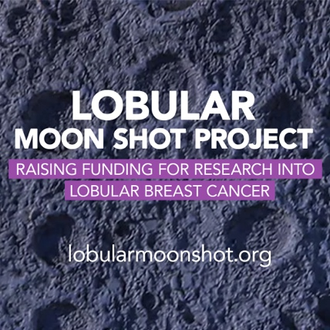

INSERT YOUR ADDRESS HERE

INSERT THE ADDRESS OF ORGANISATION

Ref: Lobular Breast Cancer

INSERT DATE HERE

INSERT NAME – Contact the company to get the correct person to write to

On behalf of the Lobular Moon Shot project, I am writing to you about lnvasive Lobular Breast Cancer. This is unique sub-type of breast cancer that evades screening, and has been ignored and forgotten by the both the scientific and health communities. Likely you have never heard of it, but it urgently requires your support for the reasons set out below.

We are therefore asking NAME OF ORGANISATION to commit to providing substantial sponsorship, so as to invest in an ignored type of women’s health. Please find further details below.

One in seven women will be diagnosed with breast cancer in their lifetime. The second most common type of breast cancer is Invasive Lobular Breast Cancer (ILC). 1,000 people a day are being diagnosed with ILC, a breast cancer that generally fails to be seen on mammograms and which is impacting people in insert your country as well as globally.

Currently, ILC has no specific treatment but with research funding, the Institute of Cancer Research in London (ICR), one of the leading research institutes internationally, has advised that it has the capability to work out the exact biology of ILC. This would enable ICR to then develop a specific treatment for those diagnosed and provide better outcomes.

The Lobular Moon Shot Project was set up in 2023 to raise this urgently needed research funding. It is run by a number of women diagnosed with ILC and their families.

We urge (insert name of organisation) to support the Lobular Moon Shot Project and get ICR the funding they urgently need to ultimately develop specific treatments for Invasive Lobular Breast Cancer. All donations go direct to the ICR lobular fund. Further details at:
https://www.lobularmoonshot.org/donate)

ILC is often called the ‘forgotten’ or ‘hidden’ cancer. It has been known since the mid 1970s that ILC behaves very differently to the most common type of breast cancer (Invasive Ductal Breast Cancer - IDC). However, to date, it is not diagnosed or treated differently to IDC.

Our Lobular Moon Shot Project, (supported by educational films on our website which we encourage you to watch), is setting out to change this globally so that people diagnosed with ILC are afforded better longer term outcomes.

Key problem areas relevant to ILC are as follows:

- ILC generally fails to show up on mammograms/ultrasounds, the main form of breast cancer early detection screening (cells run in single lines - like a spider’s web, rather than forming a lump);
- ILC is usually diagnosed much later and at a more advanced stage;
- ILC does not have its own specific treatment, despite showing differing clinicopathological and biological features (Oesterreich, 2022, Van Baelen, 2022);
- Poorer long-term outcomes for ILC patients;
- Reoccurrences can occur 10 years+ after initial diagnosis, whereas the standard breast cancer approach finishes at 5 years;
- Research funding has effectively all gone to the main type of breast cancer – IDC;
- ILC is the 5th main type of female cancer in terms of numbers. It is more common than skin/melanoma, ovarian and brain cancers;
- 1000 people a day are globally diagnosed with ILC, which will equate to almost 4 million newly diagnosed cases in the next 10 years (WHO). In Europe, for example, in 2022, 576,300 women were diagnosed with breast cancer, of which 86,500 will have been lobular breast cancer;
- 1% of breast cancers occur in men including lobular breast cancer.

The lack of a specific treatment for ILC is a global problem. There are pockets of research going on internationally with a lobular focus, but it is far from enough. The larger breast and cancer charities have not given ILC the focus and funding that it requires.

Under the banner of the global ‘Lobular Moon Shot Project’, we asked the ICR to draw up a research proposal for their dedicated focus on ILC. This is attached for your perusal. They have outlined that they require ultimately £20 million GBP to undertake this research project.

Please can you ask (name of organisation) to support the ICR ‘Lobular Moon Shot Project’. This will benefit citizens of every country, people all facing the same current problem. Being diagnosed with a disease with no specific treatment – this research project can change this.

On behalf of all those diagnosed with lobular breast cancer including those in (your country), we look forward to receiving your proactive response. This would help ensure a specific treatment becomes available as soon as possible to end what is effectively a one size fits all approach to breast cancer.

We of course would be pleased to discuss with you how best to promote that you are doing something to change the face of ILC, ensuring it is no longer the forgotten and hidden form of breast cancer.

Yours sincerely,

INSERT YOUR NAME
INSERT YOUR DIAGNOSIS DATE e.g. Diagnosed with ILC in 2013 – Metastatic ILC in 2021
INSERT YOUR EMAIL ADDRRESS

