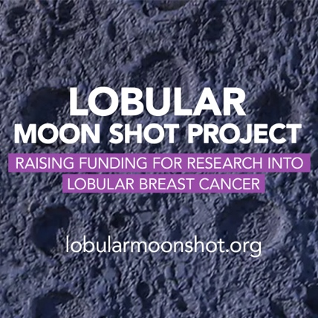

INSERT YOUR ADDRESS HERE

INSERT THE ADDRESS OF YOUR MP

Ref: Lobular Breast Cancer

INSERT DATE HERE

Dear INSERT NAME

I am writing to you about lobular breast cancer. I have (or my sister….. has) Invasive Lobular Breast Cancer (ILC). I/my sister/wife/daughter/mother….was (brief summary – max 3 lines, such as…. my lobular breast cancer was missed on mammogram screening xx times and I was finally diagnosed with xx lobular breast cancer in XXXX……

OR

I am writing to you as I have heard about lobular breast cancer (ILC) on the news and realise that it does not currently have specific treatments. The disease is difficult to detect and should someone I know be diagnosed, I would like to think they were being treated with a tailor made treatment based on the science for this specific cancer and not using generic breast cancer treatments.

I writing to ask you to please pledge your support to the Lobular Moon Shot Project, a project that is important to me and everyone dealing with lobular breast cancer. The project is supported by over 463 MPs and is the most bipartisan politically supported campaign in the history of the British nation. It was set up in 2023 by Dr Susan Michaelis to persuade the Government to fund a 5-year £20 million research project into the basic biology of a disease that has no specific treatment, frequently fails to show on a mammogram or ultrasound and remains what scientists call an ‘unmet clinical need’. Dr Michaelis passed away on the 9th of July 2025, eight different generic breast cancer treatments were unable to prevent the disease progression because she was never provided with a specific treatment for the disease she had.

The Lobular Moon Shot Project is run by a number of volunteer women diagnosed with ILC and their families. I attach a briefing sheet on the project for your perusal

Yours sincerely,

INSERT YOUR NAME

INSERT YOUR EMAIL ADDRRESS



